**Final Assignment *- Art in Nature***

May 26th – June 5th

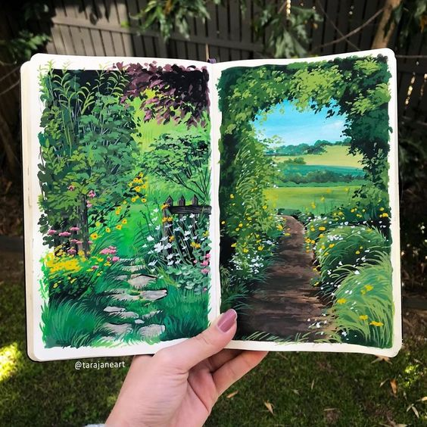

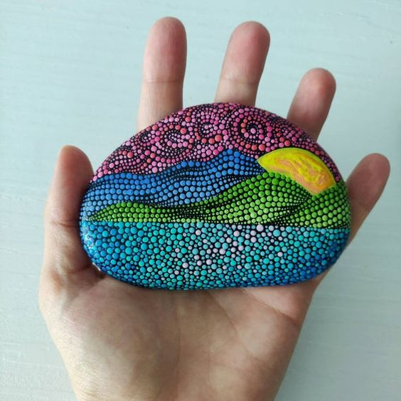Your final project is here! For this assignment titled *Art in Nature*, you are going to get outdoors! The weather is getting nicer and I want you to make the most of it! Go for a walk or a hike, sit on your front porch, or go into your own backyard. Take a look at the environment. Sit and really feel the sun on your face, feel the breeze, listen to the sounds around you and really take in the nature that is around you.

For this final project **I am leaving the medium up to you! This means you choose the materials.** Throughout the school year we practiced drawing, painting and working 3-dimensionally. These last weeks I have challenged you to use some non-traditional materials (food & found objects). This is your chance to show me what you’ve learned throughout the year and what materials you like the best!

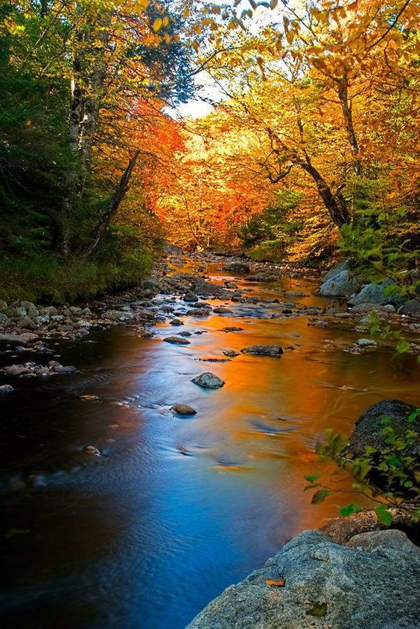 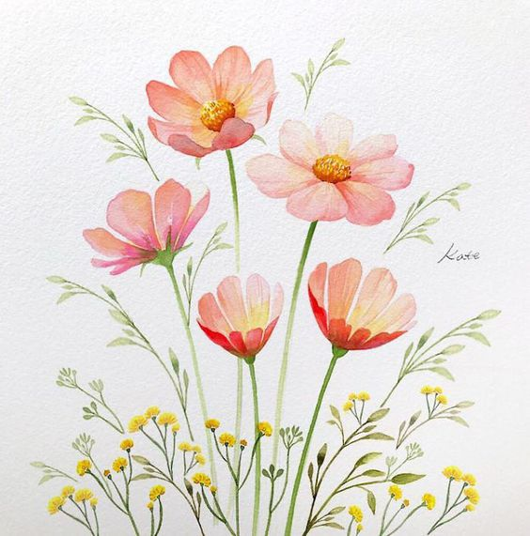 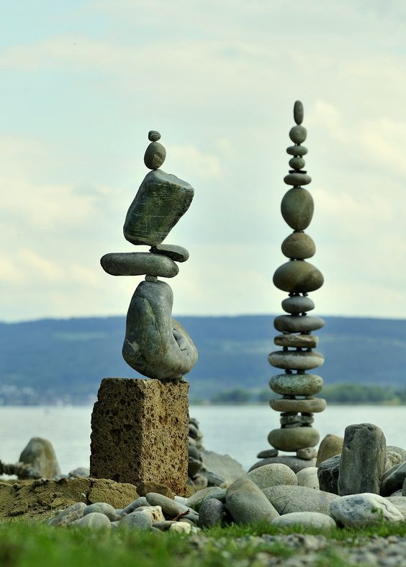 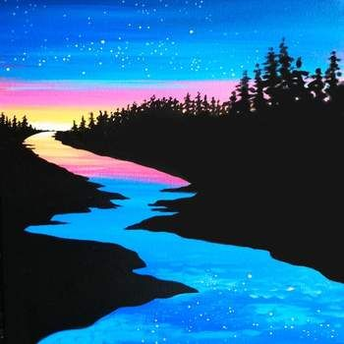

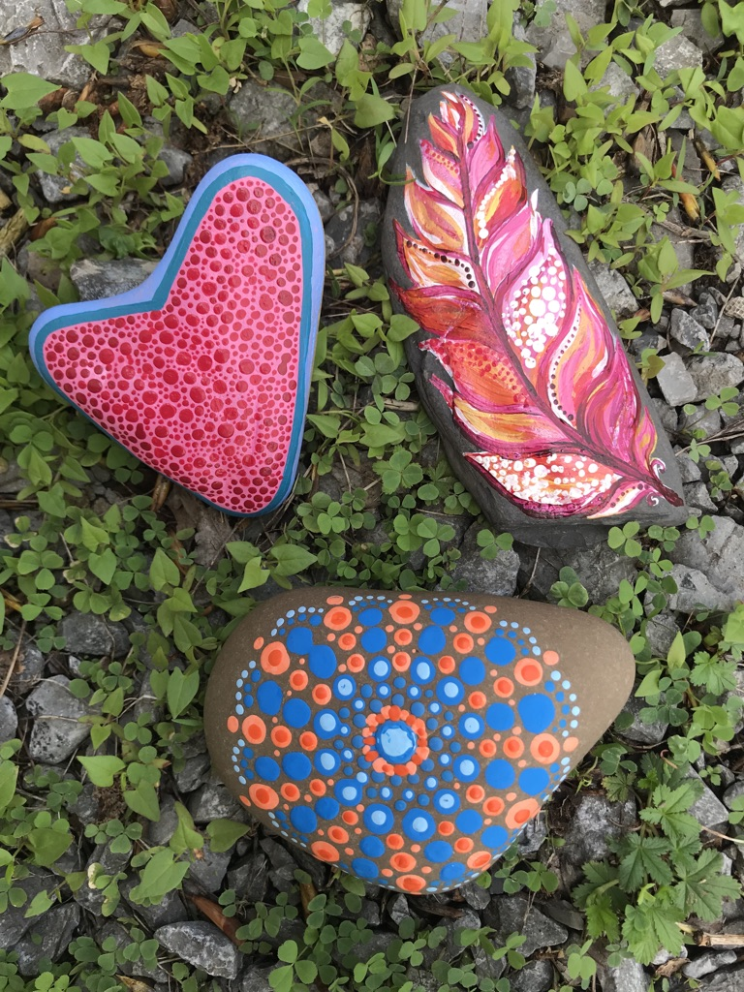**MEDIUM EXAMPLES**

* 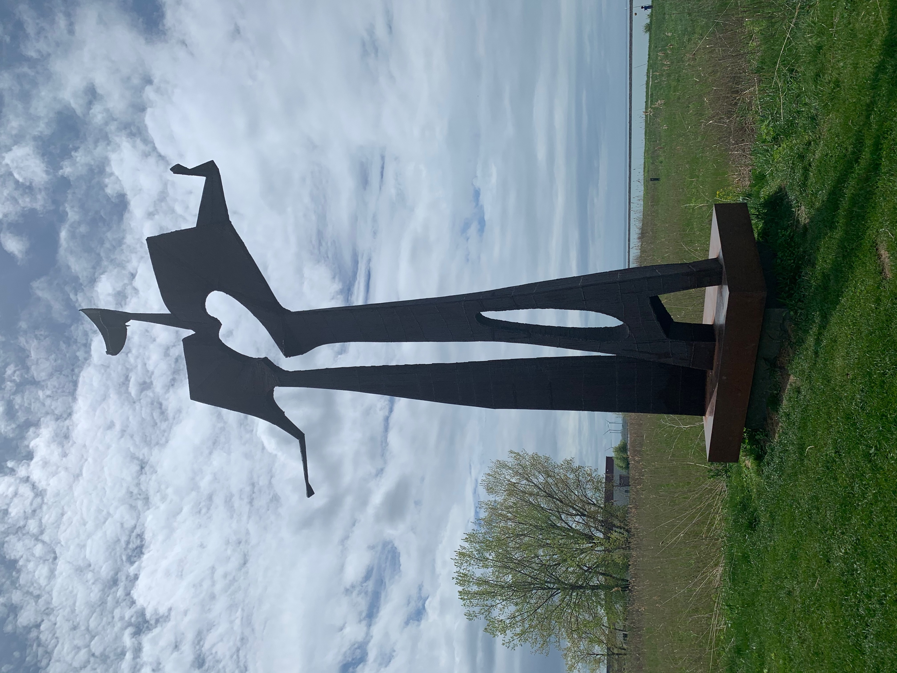Pencil or Pen/Ink
* Paint
* Markers
* Collage or Mixed Media Collage
* Photography Collage
* Items from Nature
* Video of some kind
* Non-Traditional Items

ANYTHING goes!

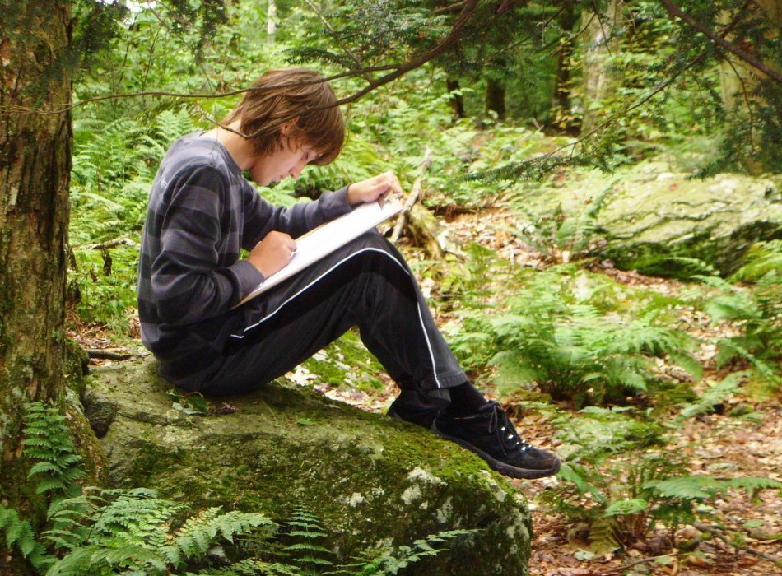

You may work in **Plein air**. Or take a photo and go back inside to work if weather is not cooperating!

***What is plein air technique?***

En **plein air** is a French expression that means *“in the open* ***air****.”* It is used by artists to describe the art of outdoor painting, capturing landscapes and views in natural light.

**REQUIREMENTS:**

* You will create your FINAL and BEST work of art, **inspired by nature**.
* Your artwork should take **at least ONE HOUR** to create. It is very clear to me when something took 5 minutes vs. 60 minutes.
* Reflection – You need to answer the reflection questions and send along with your photo.

*NOTE:* Failure to meet these requirements will result in points taken off.

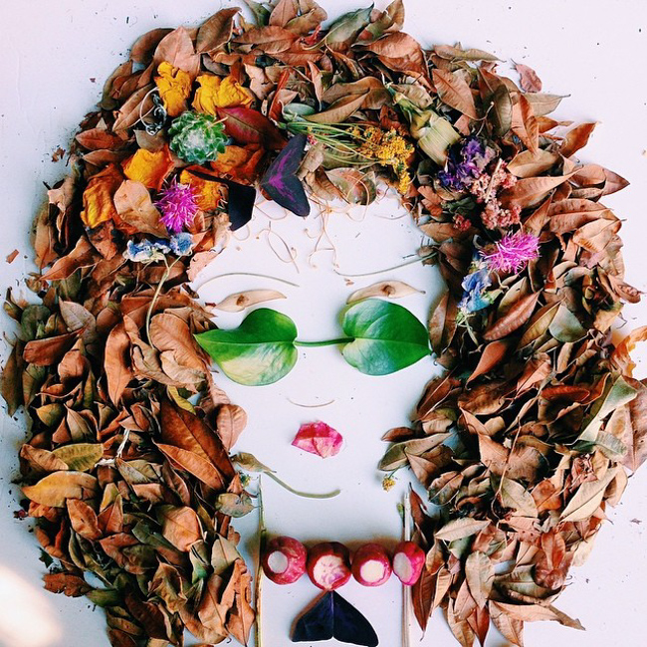**Step 1: GET OUTSIDE**

PLEASE Be safe about this! Don’t go meet up with all of your buddies to go fishing! Wear a mask if you will be around others.

Use your 5 senses to take in your surroundings. What do you ***See? Hear? Smell? Taste? Touch?***

**Step 2: PLANNING -** *What medium will you use to create your artwork? What will your subject matter be?*

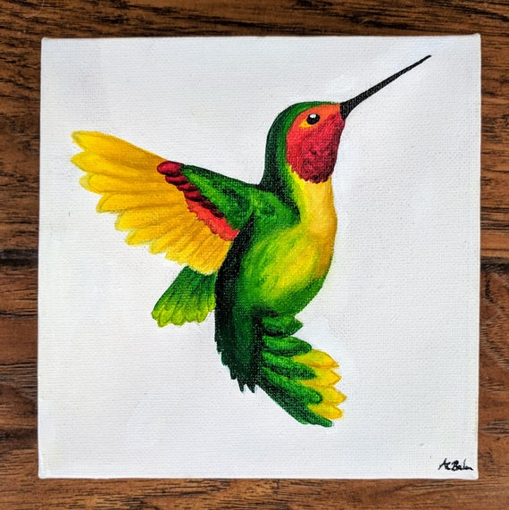**Examples of what to create**

* Drawing of the scenery/landscape (foreground/mid-ground/background)
* Still life of a single image such as a branch or flower (As much detail as you can see)
* Picture taken of a bird and then recreated with a medium of your choice
* Painting of a garden/tree
* A 3-D work created with found natural objects
* A photo collage with pictures from your outdoor adventure

The Possibilities are endless! Take the time and enjoy the outdoors. Relax. Take this time to reflect on your thoughts and ideas and BREATH.

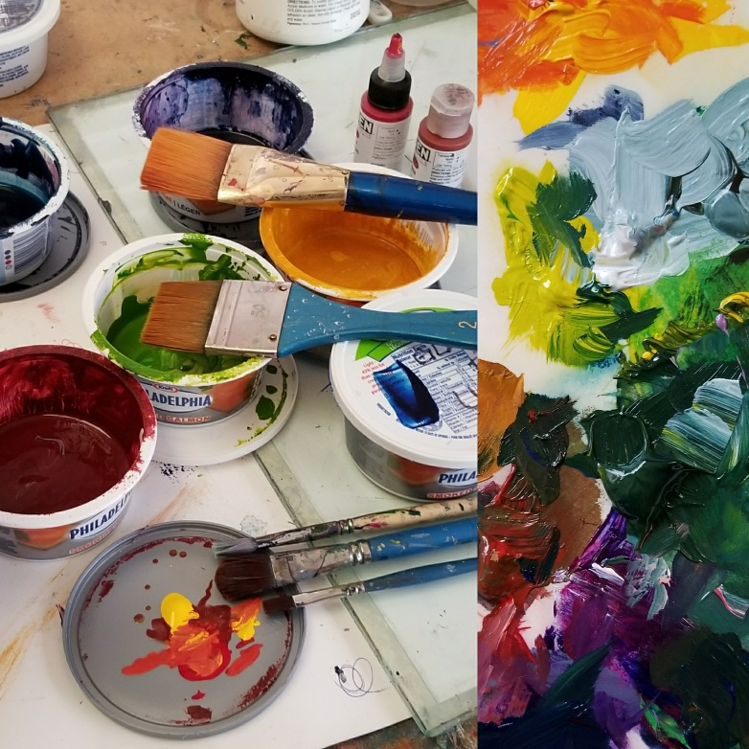**Step 3: CREATE YOUR ARTWORK**

* Take progress pictures! It’s exciting to see how a piece comes along.
* Build on a clean surface. If you’re working outside, be mindful of your surroundings.
* When you’re finished, snap a clear photo of your work!

**Step 4:** **REFLECT** – *Answer the following questions in paragraph or bullet form.*

* What was your experience in nature – where did you go? What did you see? Smell? Hear? Touch? Taste?
* Explain what you have chosen to create for this final assignment.
* What materials did you use and why?
* What do you like about your final artwork? Did you surprise yourself?
* If anything, what would you change about your artwork? Did you face any challenges while creating this piece of art?

**Step 5: SUBMIT WORK -** *Please send a picture of your artwork AND your reflection.*

How can you send your work? 1 of 3 ways.

1. Send through Office 365 TEAMS (each of you have an account and are already added to your class TEAM)
2. Send through the Remind app
3. Email to me at [cswiatek@nfschools.net](mailto:cswiatek@nfschools.net)

**DUE FRIDAY JUNE 5th**

Check out some of the amazing artist’s and examples below for ideas!

Please contact me if you need help.

**EXAMPLES & MEDIA IDEAS:**

*Drawing*

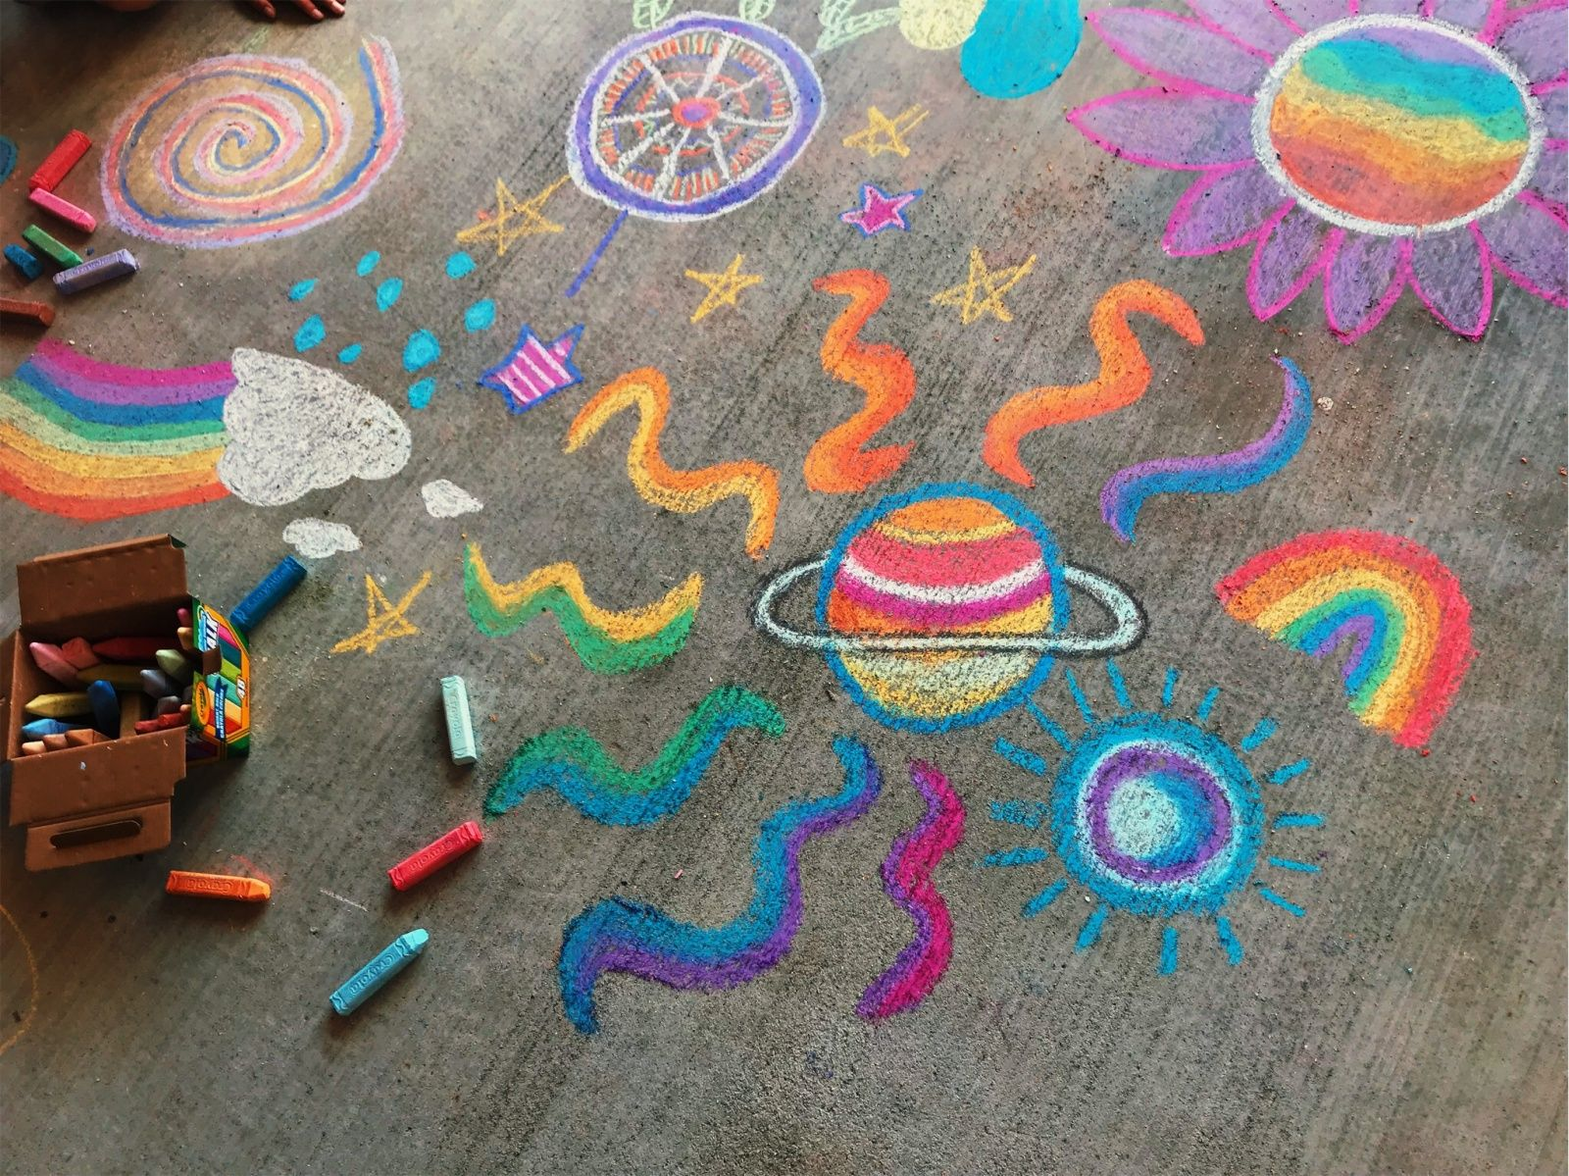 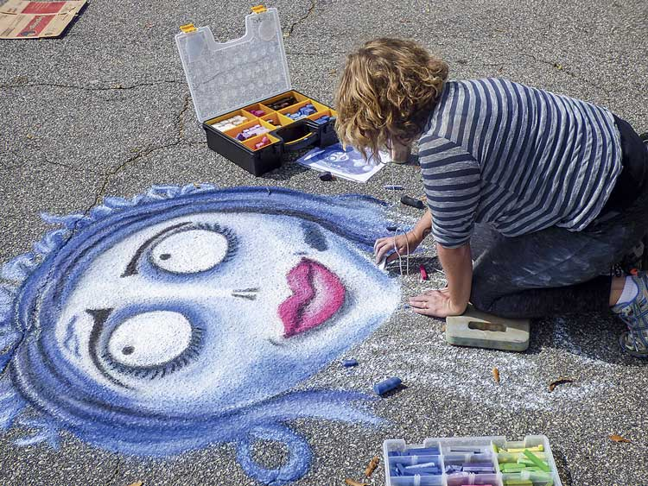

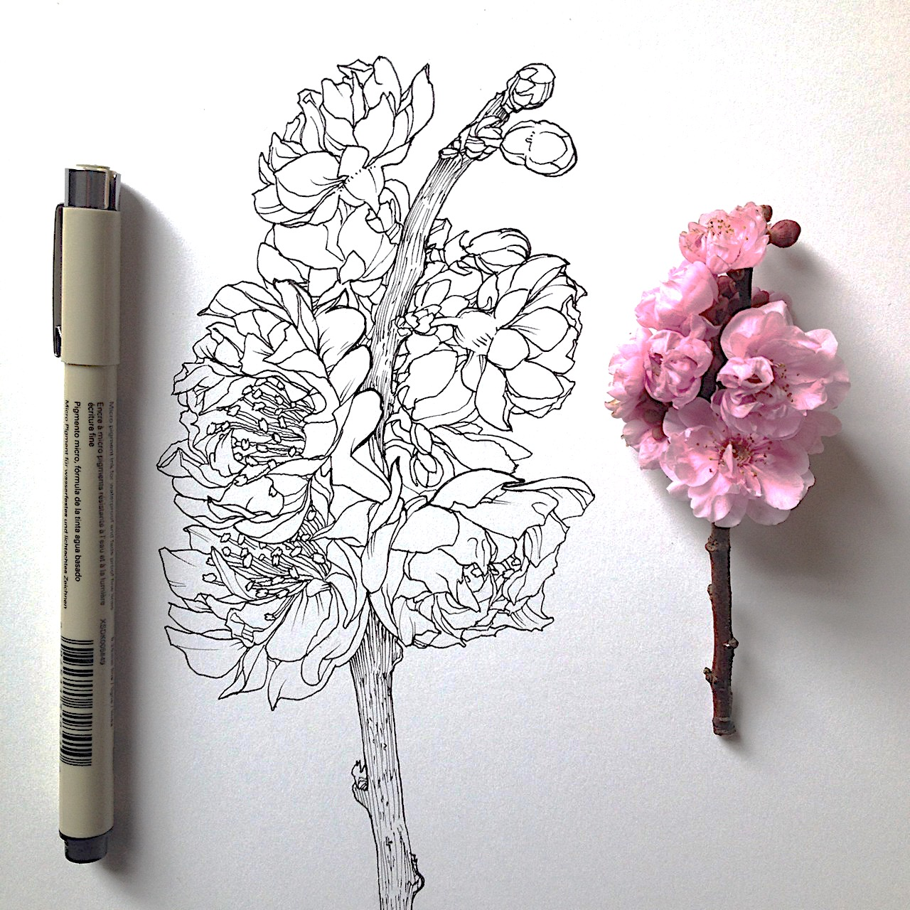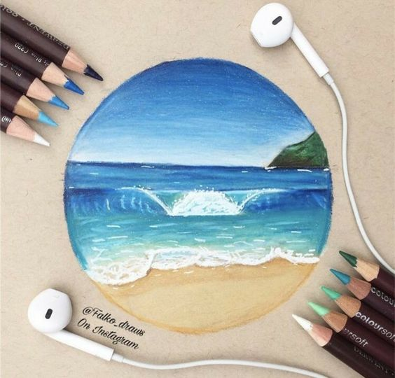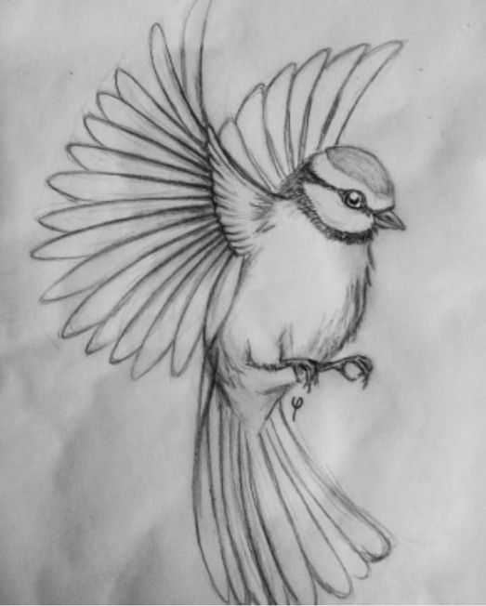

*Painting*

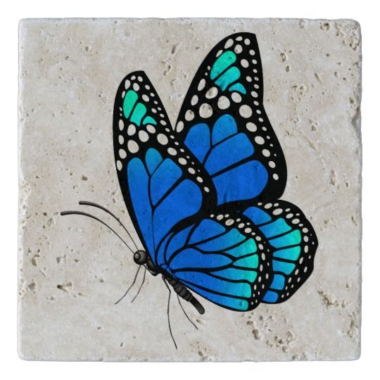 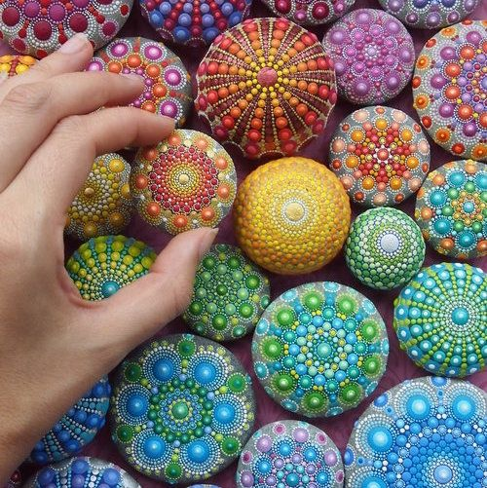 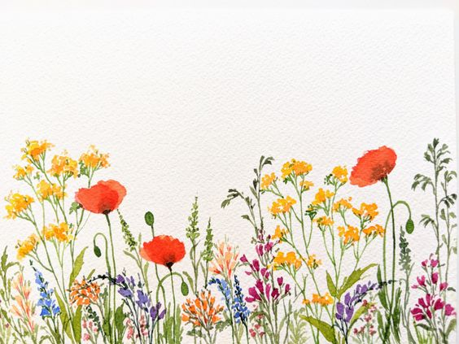

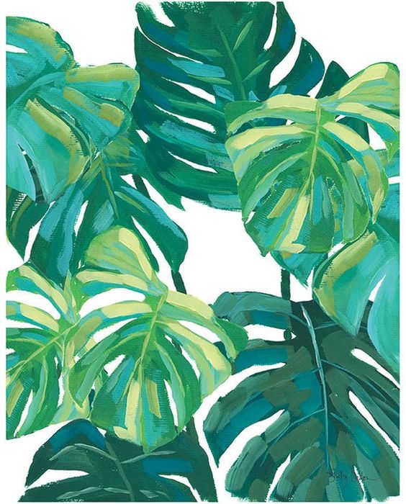 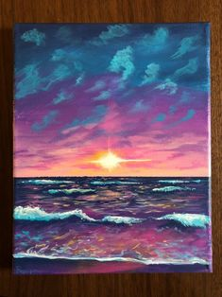 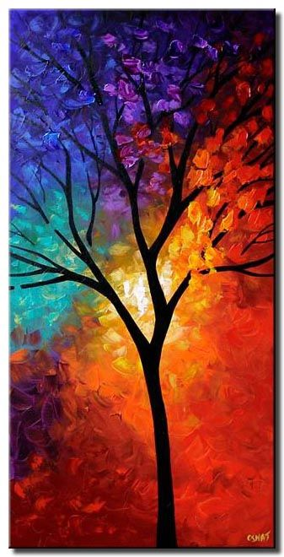

***3-Dimensional***

